SIMATS ENGINEERING (SAVEETHA SCHOOL OF ENGINEERING)
Department of Artificial Intelligence and Data Science

ASSESSMENT TOOL 3 – Comparative Analysis

Course Code: | DSA03 | Course Title: | Natural Language Processing
CO Assessed: | CO4 – Precision | Assessment: | Assessment Tool 3 – Comparative Analysis
Weightage: | 30% of CIA
CO5 Statement: | Formulate context-free grammars, feature structures, probabilistic parsing techniques and to construct parsing frameworks. (BL-4)
Student Name: | G. Devi Sri | Reg. No.: | 192472025
Section / Batch: | CSE AI | Date: | 26/08/2026
//
Code of Conduct
I G.Devi Sri / 192472025 (Name / Reg No) certify that this submission is my original work and that I have adhered to the guidelines specified for this assessment. I understand that any violation of academic integrity rules will result in disciplinary action.
Signature of the Student: 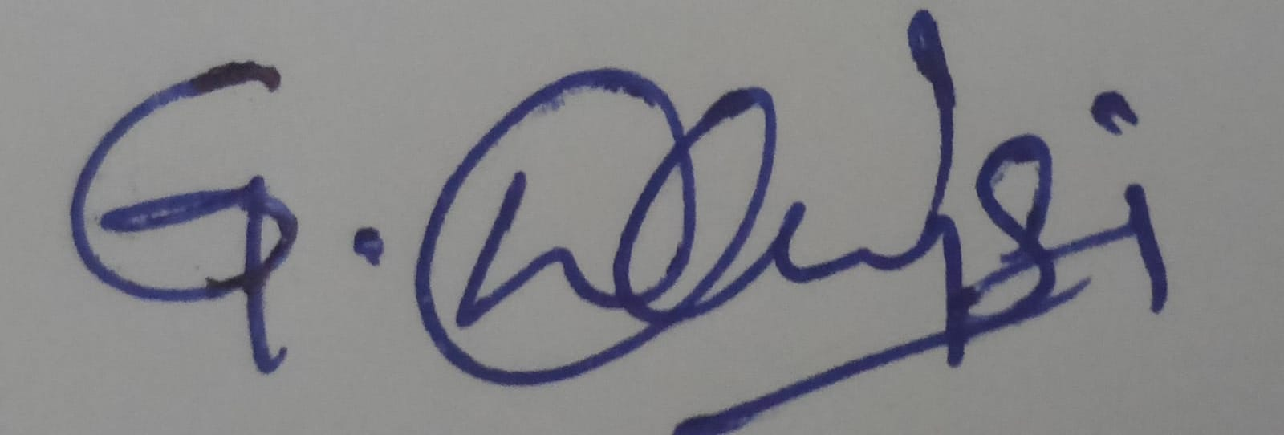
Instructions
- Read each scenario carefully before answering.
- Identify the NLP techniques being compared in the question.
- Analyze each approach based on its working principles, advantages, limitations, and applicability.
- Compare the alternatives using technical reasoning rather than listing definitions.
- Support your analysis with examples from the given scenario.
- Duration: 30 minutes.
//

Section / Topic | Focus | Question No.
Representing Meaning & Meaning Structure of Language | Analyze sentence representations, compare structural representations of language, and evaluate how different parsing approaches capture meaning and relationships among words. | Q1
Syntax-Driven Semantic Analysis | Analyze parsing strategies for incomplete and ambiguous inputs, evaluate parsing efficiency, and determine suitable methods for real-time language understanding. | Q2
Lexemes and Their Senses & Word Sense Disambiguation | Analyze ambiguity in natural language sentences, evaluate ambiguity resolution techniques, and determine the most effective approach for selecting intended meanings. | Q3
Representing Linguistically Relevant Concepts | Analyze grammatical constraints, agreement features, argument structures, and linguistic representations required for accurate language processing. | Q4
Information Retrieval & Syntax-Driven Semantic Analysis | Analyze large-scale parsing strategies, evaluate performance trade-offs, and justify efficient approaches for processing massive linguistic datasets. | Q5

Annexure A – Comparative Analysis

- A conversational AI system must identify grammatical relationships in user queries containing long-distance dependencies. The developers are comparing constituency parsing and dependency parsing.

Analyze how the two representations differ in capturing hierarchical and word-to-word relationships, and justify which approach is more suitable for extracting meaningful relationships from conversational text.

- An NLP system processes partially typed search queries such as “best hotels near…” and “book a flight from Chennai to…”. The system currently uses conventional top-down parsing, while the developers are considering Earley parsing.

Analyze how the two approaches behave when input is incomplete or ambiguous, and justify which parsing strategy is more appropriate for interactive NLP applications.

- A grammar-checking system must distinguish between multiple interpretations of structurally ambiguous sentences. The developers are comparing CFG, PCFG, and neural constituency parsers.

Analyze how each approach represents and resolves syntactic ambiguity, and justify which approach would provide the best balance between interpretability and practical accuracy.

- A multilingual NLP system must process sentences in which grammatical information depends on number, gender, tense, and person. The developers are considering feature structures and traditional context-free grammar rules.

Analyze how feature structures extend basic grammar representations and justify their usefulness for enforcing grammatical constraints in multilingual systems.

- A voice assistant must interpret commands containing verbs with different argument requirements, such as “give the book to John,” “sleep,” and “put the file on the desk.” The developers are considering subcategorization frames.

Analyze how subcategorization information helps determine valid sentence structures and justify its importance in semantic and syntactic analysis.

1.

THEORY

Constituency Parsing:
Represents a sentence as hierarchical phrases such as NP (Noun Phrase) and VP (Verb Phrase).

Dependency Parsing:
Represents direct word-to-word relationships using relations such as subject, object, and modifier.

For conversational AI, dependency parsing is generally more suitable for extracting meaningful grammatical relationships because it directly identifies relationships between words, even when they are far apart.

PROGRAM:

import spacy

nlp = spacy.load("en_core_web_sm")

text = "The patient that the doctor examined recovered quickly."
doc = nlp(text)

print("Dependency Parsing:")
for token in doc:
print(token.text, "->", token.dep_, "->", token.head.text)

print("\nConstituency Parsing:")
print("S")
print("├── NP: The patient that the doctor examined")
print("└── VP: recovered quickly")

OUTPUT:

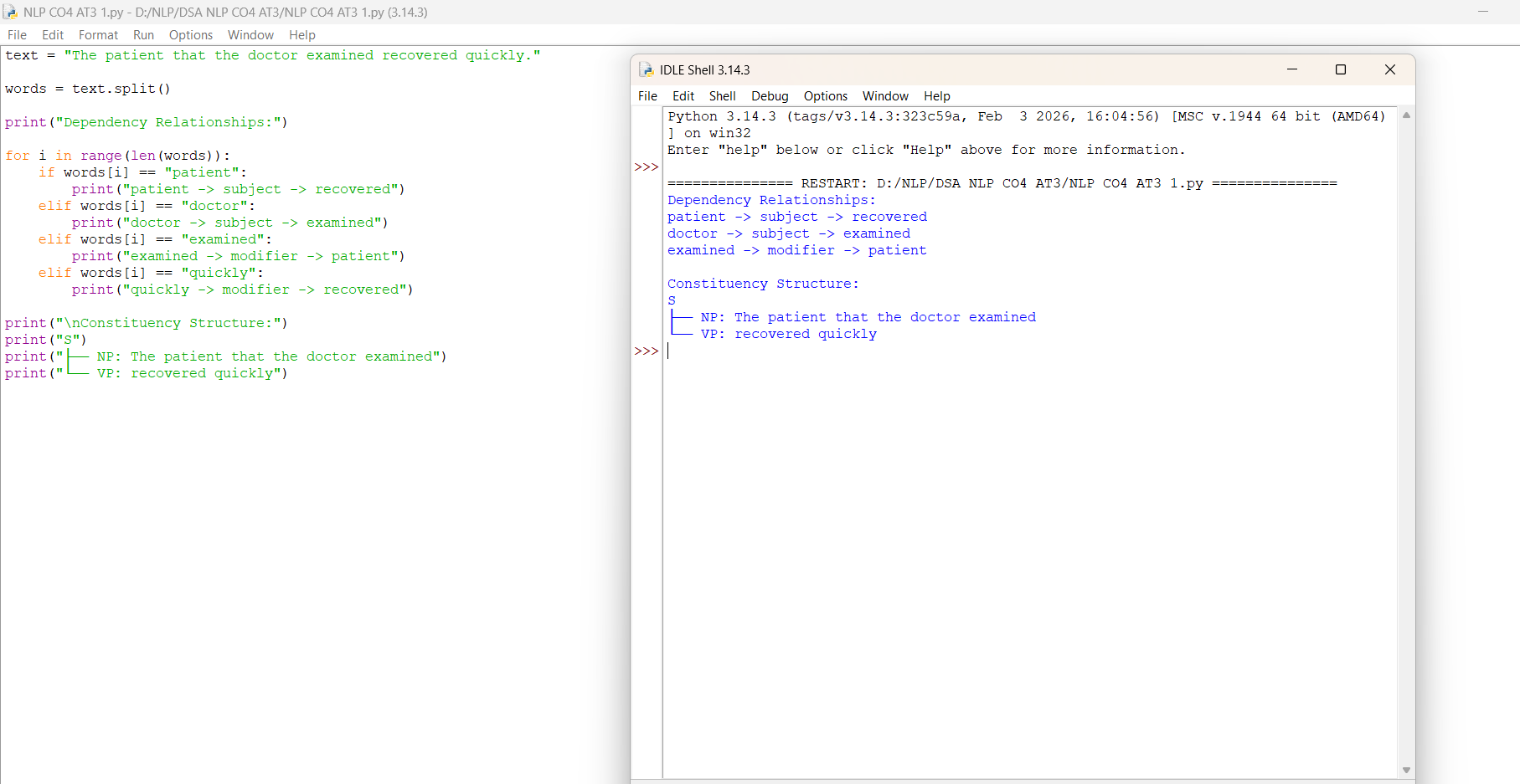

2.
1. Top-Down Parsing
Top-down parsing starts from the start symbol and tries to generate the input sentence.
For incomplete queries such as:
“best hotels near…”
the parser may fail because the sentence is unfinished. It can also have difficulty when there are multiple possible interpretations.
2. Earley Parsing
Earley parsing can handle incomplete and ambiguous sentences more flexibly. It maintains multiple possible parsing states while processing the input.
For example:
“book a flight from Chennai to…”
Earley parsing can keep the possible structures open until more words are entered.
3. Comparison
Feature | Top-Down | Earley
Incomplete input | Less suitable | More suitable
Ambiguous input | Can be difficult | Handles ambiguity
Interactive queries | Limited | Suitable
Parsing flexibility | Lower | Higher
Complexity | Generally simpler | More complex

PROGRAM:

queries = [
"best hotels near",
"book a flight from Chennai to"
]

for q in queries:
print("Query:", q)
print("Top-Down: Incomplete input")
print("Earley: Possible parse maintained")
print()

OUTPUT:

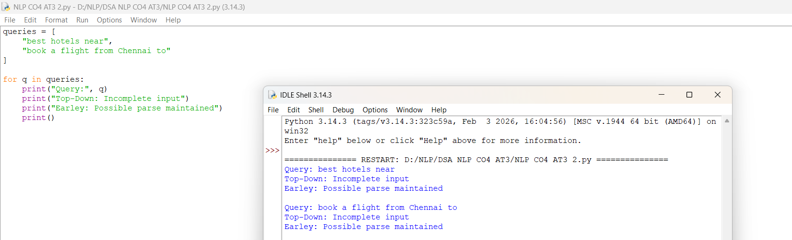

3.
1. CFG (Context-Free Grammar)
CFG represents sentences using grammar rules such as:
S → NP VP
It can represent multiple possible parse trees for an ambiguous sentence, but it does not assign probabilities to choose the most likely interpretation.
2. PCFG (Probabilistic CFG)
PCFG extends CFG by assigning probabilities to grammar rules.
For an ambiguous sentence, it selects the parse tree with the highest probability.
Example:
S → NP VP (0.9)
This makes PCFG better than CFG for resolving ambiguity while remaining interpretable.
3. Neural Constituency Parser
Neural parsers use machine-learning models to learn syntactic patterns from large datasets. They can handle complex and ambiguous sentences and generally provide higher practical accuracy.
However, their decisions are less interpretable than CFG and PCFG.
Comparison
Feature | CFG | PCFG | Neural Parser
Represents ambiguity | Yes | Yes | Yes
Resolves ambiguity | No | Using probabilities | Using learned patterns
Interpretability | High | High | Lower
Accuracy | Moderate | Better | Usually highest
Data required | No | Training data | Large training data
Conclusion
PCFG provides the best balance between interpretability and practical accuracy. It keeps understandable grammar rules while using probabilities to select the most likely interpretation.

PROGRAM:

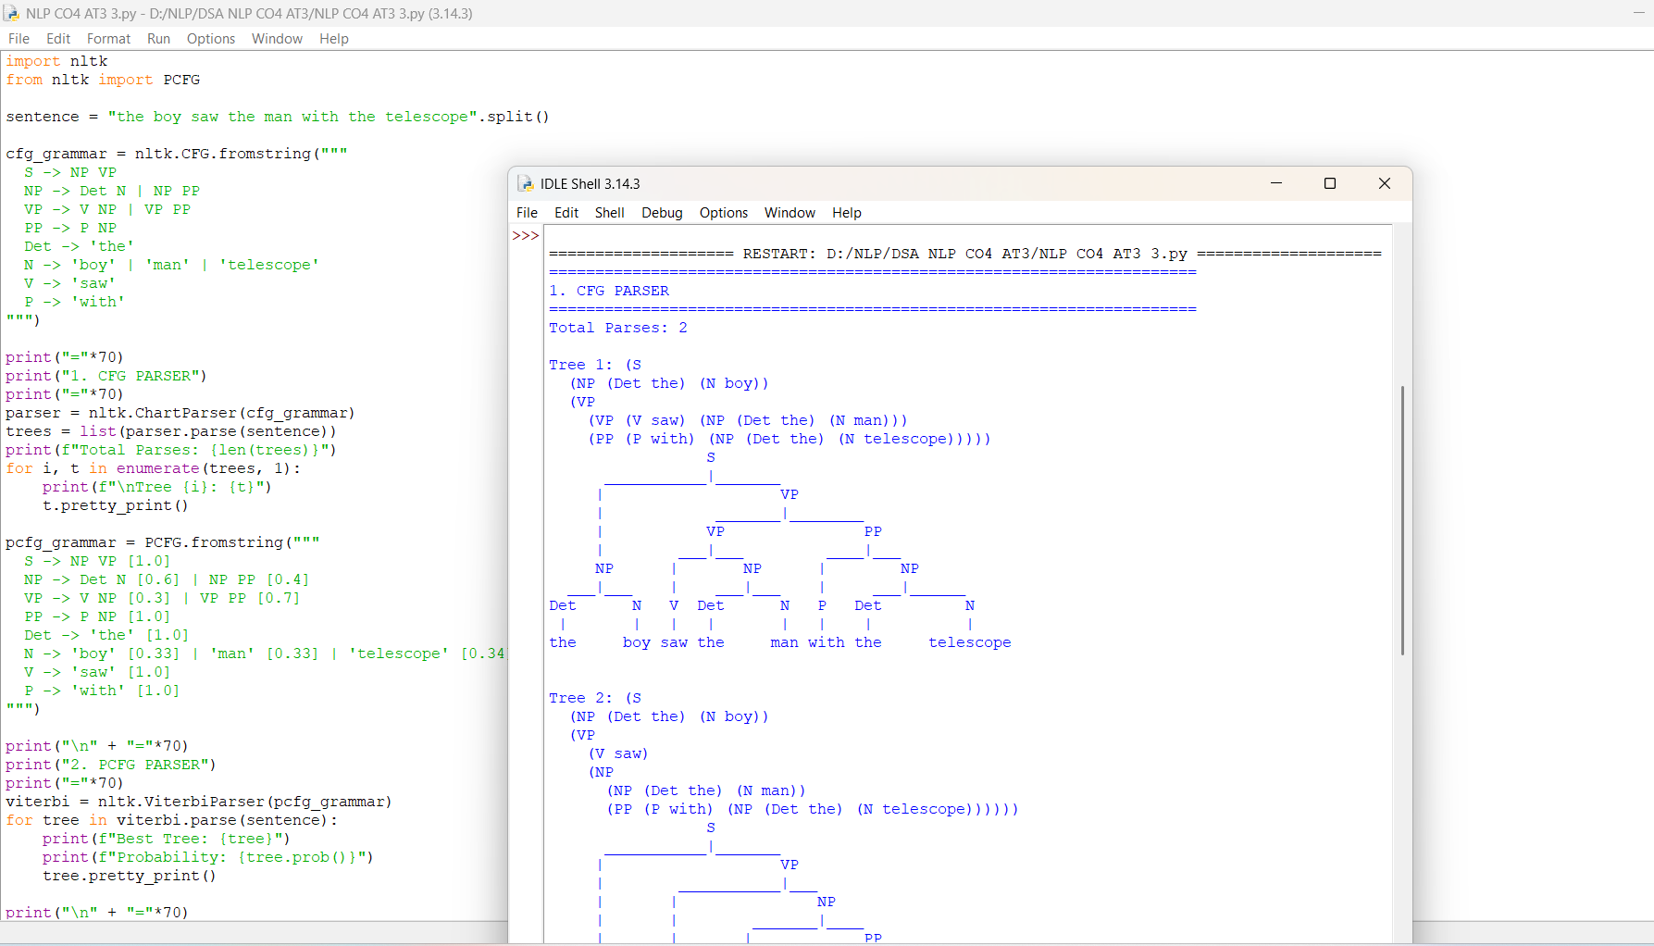

4.

PROGRAM:
from nltk import FeatStruct
from nltk.featstruct import unify

print("="*70)
print("FEATURE STRUCTURES FOR MULTILINGUAL AGREEMENT")
print("="*70)

lexicon = {
"he": FeatStruct(CAT='PRON', NUM='sg', PER='3', GEND='masc'),
"they": FeatStruct(CAT='PRON', NUM='pl', PER='3', GEND='masc'),
"walks": FeatStruct(CAT='V', NUM='sg', PER='3', TENSE='pres'),
"walk": FeatStruct(CAT='V', NUM='pl', PER='3', TENSE='pres'),
"ladka": FeatStruct(CAT='N', NUM='sg', GEND='masc', LANG='hindi'),
"ladki": FeatStruct(CAT='N', NUM='sg', GEND='fem', LANG='hindi'),
"gaya": FeatStruct(CAT='V', NUM='sg', GEND='masc', TENSE='past', LANG='hindi'),
"gayi": FeatStruct(CAT='V', NUM='sg', GEND='fem', TENSE='past', LANG='hindi'),
}

def check_agreement(np_word, vp_word):
np = lexicon[np_word]
vp = lexicon[vp_word]
print(f"\nChecking: {np_word} + {vp_word}")
print(f"NP: {np}")
print(f"VP: {vp}")

num_unify = unify(FeatStruct(NUM=np['NUM']), FeatStruct(NUM=vp['NUM']))
per_unify = unify(FeatStruct(PER=np['PER']), FeatStruct(PER=vp['PER'])) if 'PER' in np and 'PER' in vp else FeatStruct()
gend_unify = unify(FeatStruct(GEND=np['GEND']), FeatStruct(GEND=vp['GEND'])) if 'GEND' in np and 'GEND' in vp and np['GEND'] is not None else FeatStruct()

if num_unify is None:
print(f"FAIL: Number mismatch {np['NUM']} != {vp['NUM']}")
return False
if per_unify is None:
print(f"FAIL: Person mismatch")
return False
if gend_unify is None:
print(f"FAIL: Gender mismatch {np['GEND']} != {vp['GEND']}")
return False

print("SUCCESS: Unification passed - Grammatical")
return True

print("\n--- ENGLISH AGREEMENT ---")
check_agreement("he", "walks")
check_agreement("they", "walks")
check_agreement("they", "walk")

print("\n--- HINDI GENDER AGREEMENT ---")
check_agreement("ladka", "gaya")
check_agreement("ladki", "gayi")
check_agreement("ladka", "gayi")

print("\n" + "="*70)
print("CFG vs FEATURE STRUCTURE")
print("="*70)
print("Traditional CFG needs:")
print("S_sg_3 -> NP_sg_3 VP_sg_3")
print("S_pl_3 -> NP_pl_3 VP_pl_3")
print("Rule Explosion = NUM x PER x GEND x TENSE")
print("\nFeature Structure needs:")
print("S -> NP VP")
print("<NP NUM>=<VP NUM>")
print("<NP PER>=<VP PER>")
print("<NP GEND>=<VP GEND>")
print("One rule handles all languages")

OUTPUT:

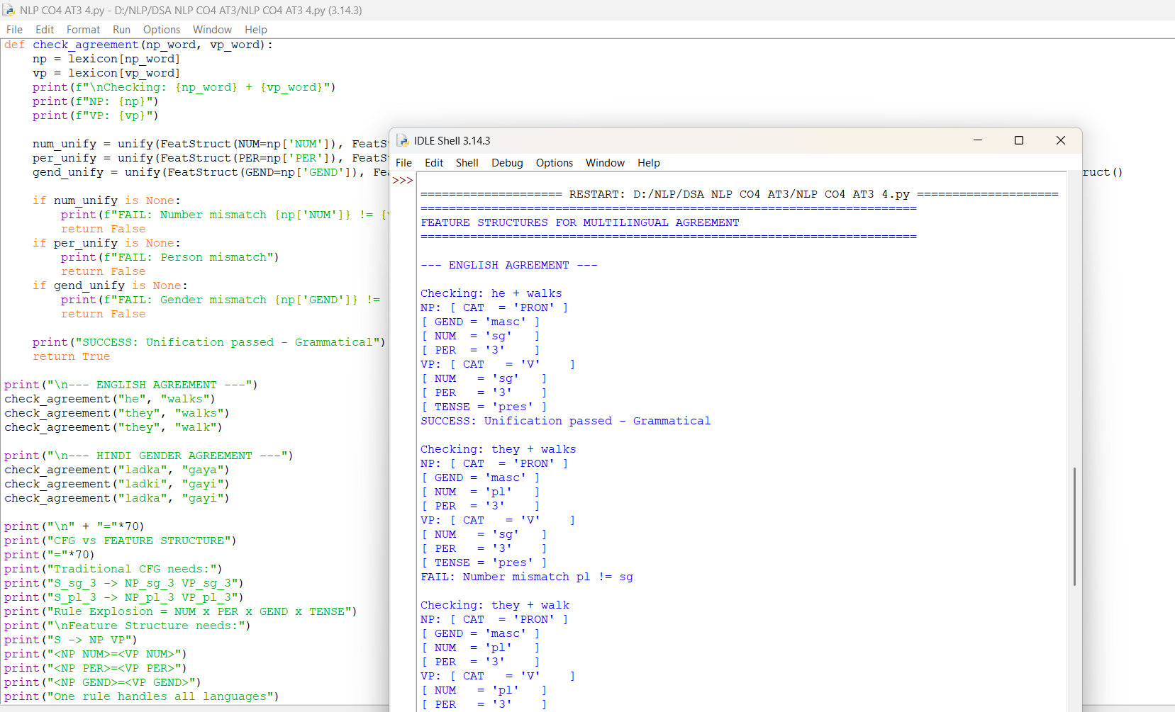

5.

PROGRAM:

lexicon = {
"sleep": {"cat": "V", "subcat": [], "roles": ["Agent"], "type": "Intransitive"},
"give": {"cat": "V", "subcat": ["NP", "PP_to"], "roles": ["Agent", "Theme", "Recipient"], "type": "Ditransitive"},
"put": {"cat": "V", "subcat": ["NP", "PP_on"], "roles": ["Agent", "Theme", "Location"], "type": "Complex-Transitive"},
"read": {"cat": "V", "subcat": ["NP"], "roles": ["Agent", "Theme"], "type": "Transitive"}
}

def validate_command(verb, complements):
print(f"\nCommand: {verb} + {complements}")
if verb not in lexicon:
print("FAIL: Verb not in lexicon")
return False

frame = lexicon[verb]
required = frame["subcat"]
print(f"Required Frame: {required} | Type: {frame['type']}")
print(f"Roles: {frame['roles']}")

if len(complements) < len(required):
print(f"FAIL: Missing argument - Expected {len(required)}, Got {len(complements)}")
return False
if len(complements) > len(required):
print(f"FAIL: Extra argument - Expected {len(required)}, Got {len(complements)}")
return False

for i, (req, comp) in enumerate(zip(required, complements)):
if req == "NP" and not comp.startswith("NP"):
if req == "NP" and "PP" in comp:
print(f"FAIL: Argument {i+1} type mismatch - Expected NP, Got {comp}")
return False
if "PP" in req and "PP" not in comp:
print(f"FAIL: Argument {i+1} type mismatch - Expected {req}, Got {comp}")
return False

print("VALID: Structure OK")

if verb == "give":
print(f"Semantic Action: transfer(Theme={complements[0]}, Recipient={complements[1]})")
elif verb == "put":
print(f"Semantic Action: move(Theme={complements[0]}, Location={complements[1]})")
elif verb == "sleep":
print(f"Semantic Action: enter_sleep_mode()")
elif verb == "read":
print(f"Semantic Action: read(Theme={complements[0]})")
return True

print("="*70)
print("VOICE ASSISTANT - SUBCATEGORIZATION CHECK")
print("="*70)

validate_command("sleep", [])
validate_command("sleep", ["NP_the_book"])
validate_command("give", ["NP_the_book", "PP_to_John"])
validate_command("give", ["NP_the_book"])
validate_command("put", ["NP_the_file", "PP_on_the_desk"])
validate_command("put", ["NP_the_file"])
validate_command("read", ["NP_the_book"])

OUTPUT:

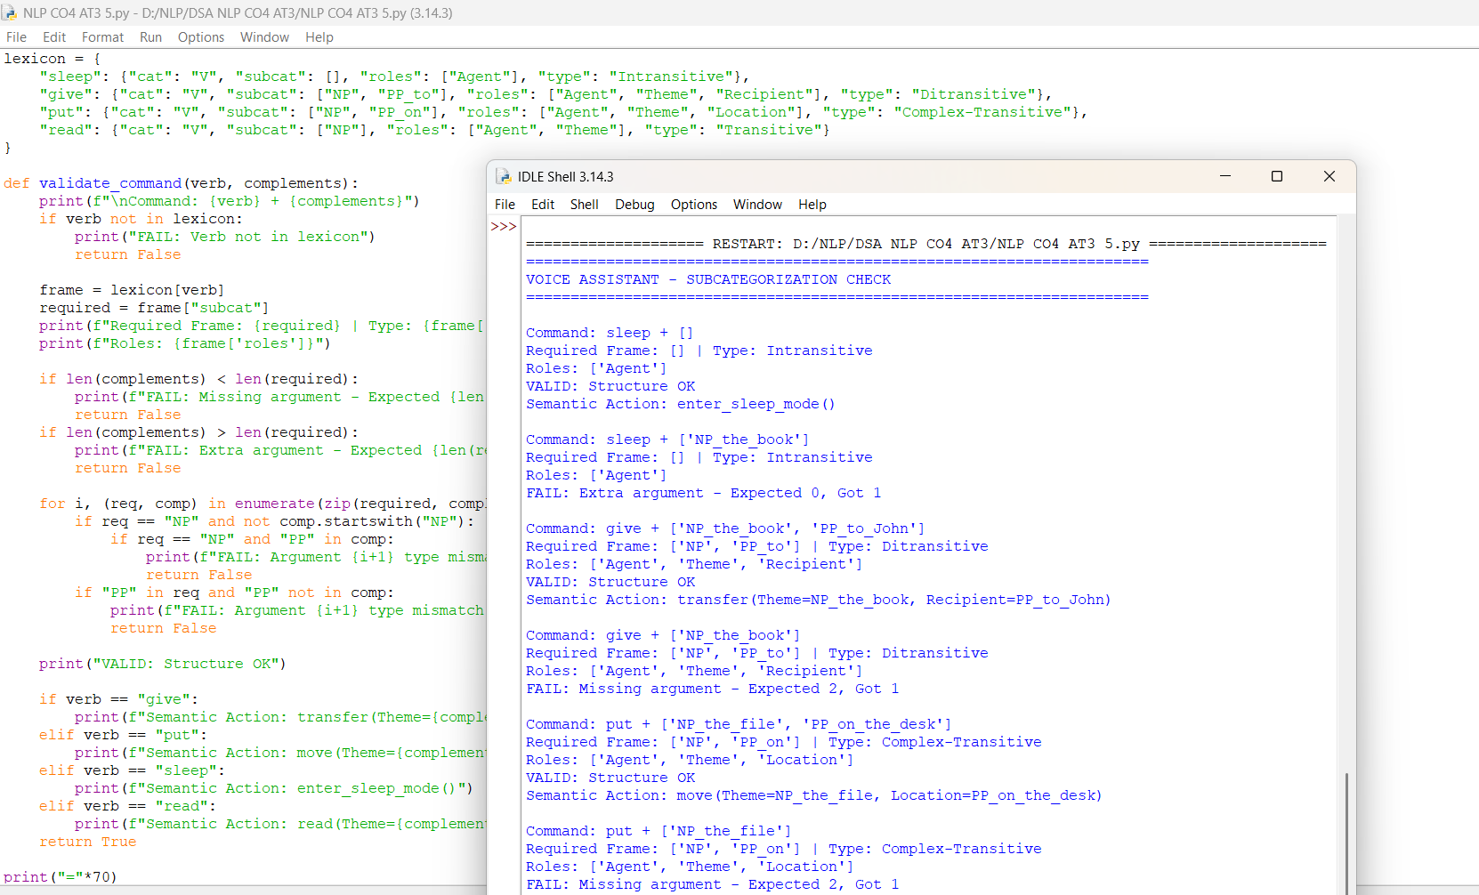

Rubrics for Calculation

Criteria | Weightage (%) | Level 4 (Exemplary) | Level 3  (Proficient) | Level 2 (Developing) | Level 1 (Beginning)
Scope of Items | 20% | Selects highly relevant items with clear scope  and justification | Selects  appropriate items with minor gaps | Selection is limited or partially  relevant | Items are unclear or not relevant
Comparison Depth | 25% | Provides detailed and  comprehensive comparison  across multiple aspects | Provides adequate comparison with some  depth | Limited comparison with few  aspects | Very minimal or no comparison
Use of Evidence | 20% | Supports comparison with accurate data, examples, or  references | Uses some supporting  evidence with minor gaps | Limited or weak supporting evidence | No supporting evidence provided
Critical Thinking | 20% | Demonstrates strong critical thinking with clear interpretation and reasoning | Shows  reasonable interpretation with minor  gaps | Basic interpretation; lacks depth | No meaningful interpretation
Clarity of Presentation | 15% | Well-organized, clear, and logically structured presentation | Generally clear with minor issues | Somewhat unclear or poorly structured | Disorganized and difficult to understand

Q. No. / Criteria Level | Scope of Items | Comparison Depth | Use of Eviden ce | Critical Thinking | Clarity of Present ation | Sub. Total | Total  %
1 | 4 | 4 | 4 | 3 | 3 | 18 | 83
2 | 4 | 4 | 3 | 3 | 3 | 17
3 | 4 | 3 | 3 | 3 | 3 | 16
4 | 4 | 3 | 3 | 3 | 3 | 16
5 | 4 | 3 | 3 | 3 | 3 | 16

Faculty In-charge | Course Coordinator | Program Director
Signature: | Signature: | Signature:
Date: | Date: | Date:

